Timberwood: Timber Oaks Phase
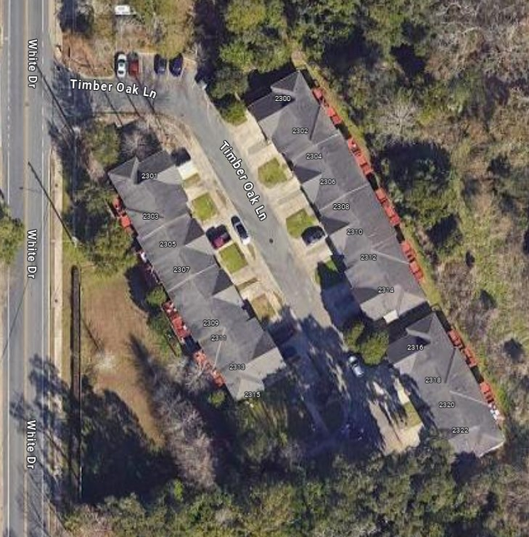
KEY
DUMPSTER
PET STATIONS
Timberwood: White Dr Phase
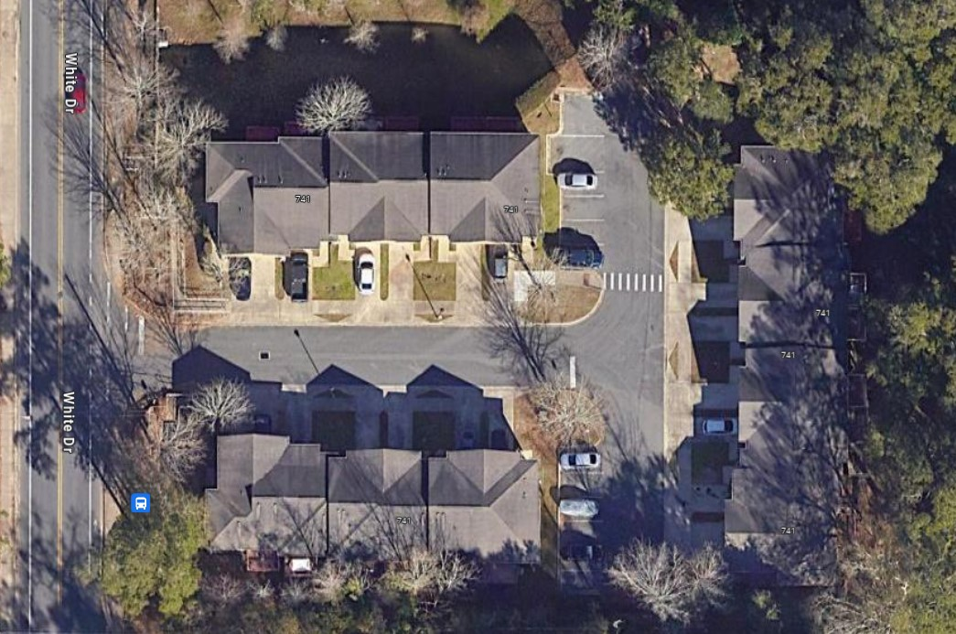
KEY
DUMPSTER
PET STATIONS

